# CS 255 System Design Document Template

## UML Diagrams

### UML Use Case Diagram

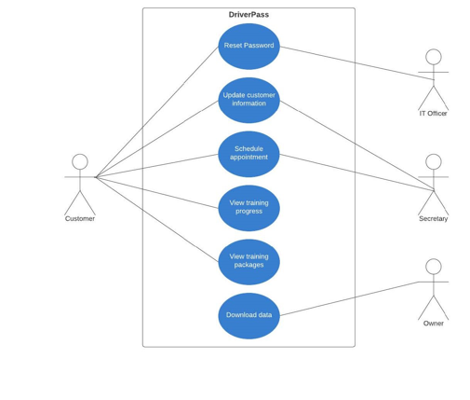

### UML Activity Diagrams

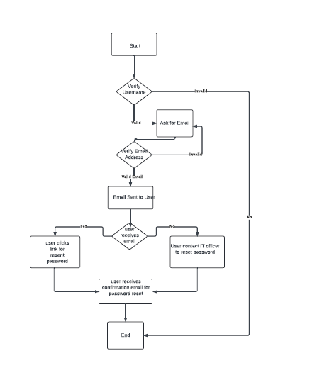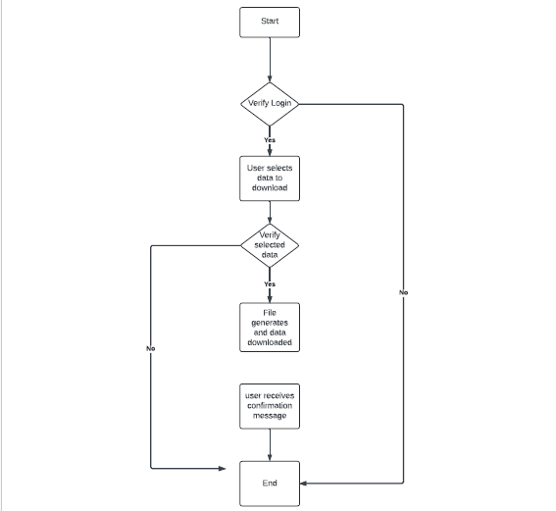

### UML Sequence Diagram

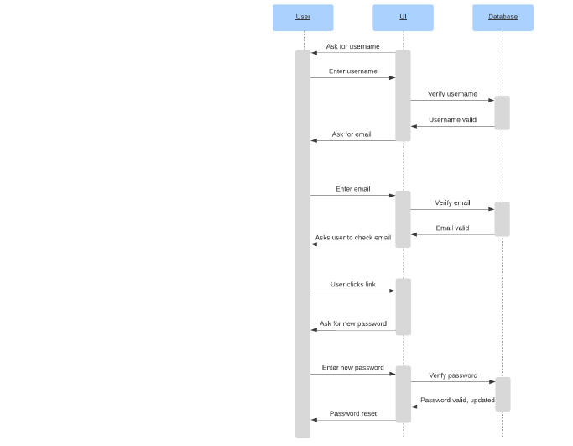

### UML Class Diagram

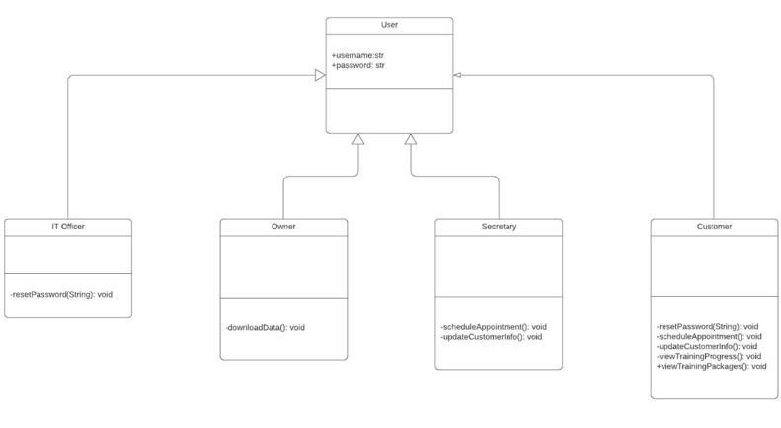

## Technical Requirements

We need to build a system by using any cloud that will be compatible with desktop and mobile. User must be able to download the data. To build this system we need a database that will store user’s login information. Based on the valid credentials, user will be able to login to the system and will be able to download the data. Any data being transferred between user and system, needs to be encrypted via SSL to ensure data integrity and security. Role-based access will need to be implemented also, as the owner can do things a customer cannot do, the IT officer can do things the secretary can do, etc.